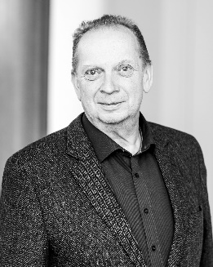

Pharmacist Dr. Alexander Schenk
Studies of pharmacy at Westfälische Wilhelms Universität, Münster/Germany, 1998 doctorate at Institute for Pharmaceutical Biology and Phytochemistry ibidem. Since 2001 professorship in phytotherapy and phytopharmacy at Ovidius University in Constanta, Romania. Since 2013 Scientific Expert Analytical Development at Max Zeller Söhne AG, Romanshorn, Switzerland.

